Chapter 10, Solution 20.

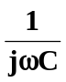
The circuit is converted to its frequency-domain equivalent circuit as shown below.
R
V_{mÐ}0°
+
-
jwL
+
V_{o}
-

Let 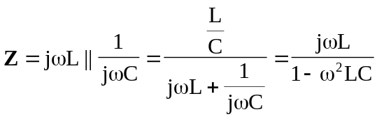

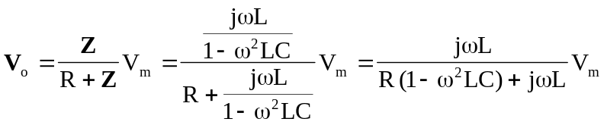
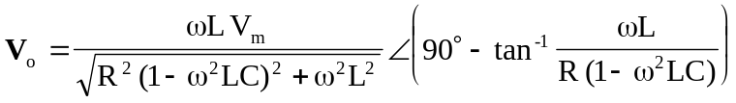

If 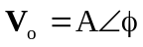, then
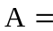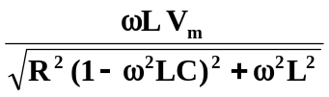

and 